**THE FEASIBILITY OF DEVELOPING**

**A SUPPLEMENTARY LEARNING TOOL FOR COMPUTER**

**LITERACY FOR STUDENTS OF MILAOR NATIONAL HIGH SCHOOL**

A Research Study Presented to

the Faculty of the College of Computer Studies

University of Nueva Caceres

In Partial Fulfillment

of the Requirements for the Degree

BACHELOR OF SCIENCE MAJOR IN COMPUTER SCIENCE

and

BACHELOR OF SCIENCE MAJOR IN INFORMATION TECHNOLOGY

by

James Robert E. Felicidario

James Roi V. Sergio

October 2016

**APPROVAL SHEET**

This research study entitled, **THE FEASIBILITY OF DEVELOPING A SUPPLEMENTARY LEARNING TOOL FOR COMPUTER LITERACY FOR STUDENTS OF MILAOR NATIONAL HIGH SCHOOL,** prepared and submitted by JAMES ROBERT E. FELICIDARIO and JAMES ROI V. SERGIO in partial fulfillment of the requirements for the degree of BACHELOR OF SCIENCE MAJOR IN COMPUTER SCIENCE and BACHELOR OF SCIENCE INFORMATION TECHNOLOGY, has been examined and is recommended for acceptance and approval for oral examination.

|  |  |
| --- | --- |
|  | JAY LEANDRO A. BORELA, MIT |
|  | Adviser |

PANEL OF EXAMINERS

APPROVED by the Committee on Oral Examination on

13NOVEMBER 2016, with a grade of _________.

|  |  |  |
| --- | --- | --- |
| MARVIN M. MONTEAGUDO, MIT | | |
| Chairperson | | |
|  |  |  |
|  |  |  |
|  |  |  |
| DEX I. NOBLEZA |  | JOGIE R. LUSTRE |
| Member |  | Member |

ACCEPTED AND APPROVED in partial fulfillment of the requirements for the degree of BACHELOR OF SCIENCE MAJOR IN COMPUTER SCIENCE and BS INFORMATION TECHNOLOGY.

|  |  |  |
| --- | --- | --- |
|  |  |  |
|  |  |  |
| JAY LEANDRO A. BORELA, MIT |  | AGNES A. TRILLANES-REYES, MIS |
| Research Coordinator |  | Dean |
| College of Computer Studies |  | College of Computer Studies |

**RESEARCH STUDY SUMMARY**

1. Title : **THE FEASIBILITY OF DEVELOPING A SUPPLEMENTARYLEARNING TOOL FOR COMPUTER LITERACY FOR STUDENTS OF MILAOR NATIONAL HIGH SCHOOL**

Total No. of Pages: 67

Text No. of Pages: 39

1. Authors : FELICIDARIO JAMES ROBERT EUSTE

SERGIO JAMES ROI VISTA

1. Type of Document: Research Study
2. Type of Publication: Unpublished
3. Institution : University of Nueva Caceres  
    J. Hernandez Avenue, Naga City
4. Keywords : Literacy, ComputerLiteracy,Feasibility

Study,Supplementary Learning Tool

1. Abstracts:
   1. **Rationale/Background of the Study**

This study is about the feasibility of developing a supplementary learning tool about computer literacy for Junior high school students of Milaor National High School by determining the possible challenges and factors that can affect the development of computer literacy skill of the students. The problems will be evaluated and use as a guide to determine the feasibility of the supplementary learning tool to the Milaor National High School. This e-learning tool will help the progress of improving the skills of the student and to be able to learn more about computer literacy.

* 1. **Summary**

This study was intended to the feasibility of developing a supplementary learning tool about the computer literacy for the Junior High school students of Milaor National High School.

Specifically, the following objectives are the researchers would like to know: (1) To determine the challenges encountered by Milaor National High School in teaching Computer Literacy to its Students along: (a) Teaching Methods (b) Teaching Tools; (2) To identify the factors that affects the feasibility study along (a) Operations (b) Technical Capability (c) Budget; and (3) To determine if there a need to develop a supplementary tool for the Computer subject in Milaor National High School.

* 1. **Findings**

It is not feasible to develop a supplementarylearning toolin Milaor National High School due to the factors that affect the feasibility of the supplementary learning tool. The researchers found out that the school does not have computer maintenance personnel to their computer lab. Another factor that affects the feasibility of the e-learning tool is that the school does not have budget to handle the supplementary learning tool.

* 1. **Conclusions**

The researchers found out that under the challenges encountered in terms of teaching tools and teaching methods the school provides sufficient tools and methods that do not hinder the progress of learning of the student in terms of computer subjects.

The researchers conclude that the factors that affect the most on the feasibility of the supplementary learning tool are the budget and technical capability. It is due to lack of budget of the school to avail the e-learning tool and by not having maintenance personnel who is responsible for maintaining the computer lab of the school.

Based on the results gathered from the challenges encountered by the school and the factors that affect the feasibility of the supplementary learning tool, the researchers therefore conclude that there is no need to develop a supplementary learning tool for Milaor National High School.

* 1. **Recommendations**

The researchers recommend that the school needs to hire computer maintenance for their computer lab and financial fund in order for the supplementary learning tool to be feasible to Milaor National High School.

**ACKNOWLEDGEMENT**

This study would not be possible without the help of the following people who supported and contributed to the researchers to make this research:

To Mrs. Arlene N. Prado, and Mr. Elmer C. Trinidad, ICT instructors on Milaor National High-School who spent time with the researchers, for giving guidance and advices during the project study presentation;

To Mrs. Anita C. San Agustin and Mr. Francisco P. Mañago, for giving access and permission for the researcher to conduct the study and to survey the students of Milaor National High School;

To the CCS Faculty of UNC, for the knowledge and guidance to finish this research;

To the researchers loving family, for giving moral support in times of hardship and downfall;

And most especially, to the great good God for the strength and guidance to accomplish this work and to pursue the right path.

J.R.E.F.&J.R.V.S.

**TABLE OF CONTENTS**

Page

TITLE PAGE . . . . . . . . . . . . . . . . . . . . . . 1

APPROVAL SHEET . . . . . . . . . . . . . . . . . . . . 2

RESEARCH STUDY SUMMARY . . . . . . . . . . . . . . . . 3

ACKNOWLEDGEMENT . . . . . . . . . . . . . . . . . . . . 5

TABLE OF CONTENTS . . . . . . . . . . . . . . . . . . . 6

LIST OF FIGURES . . . . . . . . . . . . . . . . . . . . 8

LIST OF TABLES. . . . . . . . . . . . . . . . . . . . . 8

CHAPTER

1 THE PROBLEM AND ITS SETTING

Background of the Study . . . . . . . . . . . 9

Statement of the Problem. . . . . . . . . . . 12

Objectives of the Study . . . . . . . . . . . 13

Scope and Limitations . . . . . . . . . . . . 13

Significance of the Study . . . . . . . . . . 14

Definition of Terms . . . . . . . . . . . . . 15

2 THEORETICAL BACKGROUND

Related Literature. . . . . . . . . . . . . . 17

Related Studies . . . . . . . . . . . . . . . 18

Related Applications or Systems . . . . . . . 20

Synthesis of the Arts . . . . . . . . . . . . 21

Gaps to be bridged by the Study . . . . . . . 22

Theoretical Framework . . . . . . . . . . . . 23

Conceptual Framework . . . . . . . . . . . . 24

Analytical Framework . . . . . . . . . . . . 25

3 RESEARCH DESIGN AND METHODOLOGY

Research Design . . . . . . . . . . . . . . . 27

Research Methodology.. . . . . . . . . . . . 28

Population and Samples. . . . . . . . . . . . 29

Research Instruments. . . . . . . . . . . . . 29

Validation of Research Instruments. . . . . . 30

Statistical Treatment . . . . . . . . . . . . 30

Data Gathering Procedure. . . . . . . . . . . 31

Sources of Data . . . . . . . . . . . . . . . 32

4 DISCUSSION OF FINDINGS

Statement of the Problem 1. . . . . . . . . 33

Statement of the Problem 2 . . . . . . . . . 36

Statement of the Problem 3 . . . . . . . . . 44

5 CONCLUSIONS AND RECOMMENDATIONS

Conclusions . . . . . . . . . . . . . . . . . 46

Recommendations. . . . . . . . . . . . . . . 48

REFERENCES. . . . . . . . . . . . . . . . . . . . . . . 50

APPENDICES

A Questionnaires. . . . . . . . . . . . . . . 53

B Letter – School Principal. . . . . . . . . . 65

CURRICULUM VITAE. . . . . . . . . . . . . . . . . . . . 66

**LIST OF FIGURES**

Figure No. Title Page

1 Theory of the Study . . . . . . . . . . . . . 23

2 The Paradigm of the Study . . . . . . . . . .24

3 Analytical Data of the Study . . . . . . . . 25

4 Knowledge of students on Supplementary tool . .. 37

5 Supplementary learning tool to students . . . . . 39

**LIST OF TABLES**

Table No. Title Page

1 Research Phases and Activities . . . . . . . . 31

2 Availability of Maintenance in Computer Laboratory 42

Chapter 1

# THE PROBLEM AND ITS SETTING

**Background of the Study**

Nowadays computers are one of the essential tools that people use in daily lives. Van Thompson (2017) stated that, computer is not just a device that can help you get a job. Instead, it is a tool for everyday tasks in a wide range of jobs, including administrative assistants, doctors, lawyers and scientists. It is a must for a Professional or Unprofessional individual in our generation to learn about computers whether it is basic or advance knowledge.

Being a computer literate gives opportunity to excel on fast evolving environment on technology. The ability to use more common programs such as Microsoft Word or Excel or specialized programs can mean that you have advanced computer skills that other candidates do not, and you may get hired into the company because you are able to use those programs at an intermediate or advanced level (Latzko, 2011).

Computer literacy is no longer a nice bonus to add to a resume instead, basic computer skills are mandatory job requirements and even necessary for mundane daily tasks. From researching potential jobs to writing a resume, students need computer skills even before they get a job and students who can competently research and write on a computer are better-equipped for both academic and professional success. However, not all schools are created equal when it comes to computer literacy and many students are not graduating with adequate computer skills (Thompson, 2017).

In developed countries, computer literacy is considered to be a very important skill to possess. In Australia, the majority of occupations give employees access to computers and the internet as part of their job. Having computer skills simply refers to the ability to quickly and easily navigate a computer workspace. Familiarity with office programs, such as Microsoft Word, PowerPoint, Outlook and QuickBooks used to be the standard skill set for most business operations. In terms in school, Australian schools have also incorporated technology into the school curriculums as a way to start developing the students’ computer literacy skills (Woollard, 2012).Since Philippines is still a developing country it is still good to see incoming professionals to have knowledge on computers even if the course taken is not computer related course, it is an advantage to have skills on computer.

In this study, it aimed to determine the feasibility ofdeveloping a supplementary learning tool about computer literacy for Junior high school students of Milaor National High School by determining the possible challenges and factors that can affect the feasibility of developing of the said tool. The challenges and factors will be evaluated to determine whether the school is capable to handle the supplementary learning tool which can help the progress of mastering the skills of the student and to be able to learn more about computer literacy.

**Statement of the Problem**

This study was intended to the feasibility of developing a supplementary learning tool about the computer literacy for the Junior High school students of Milaor National High School.

Specifically, the following questions are the researchers would like to know:

1. What are the challenges encountered by Milaor National High School in teaching Computer Literacy to its Students along:
   1. Teaching Methods
   2. Teaching Tools?
2. What are the factors that affect the feasibility study along:
   1. Operations
   2. Technical Capacity
   3. Budget?
3. Is there a need to develop a supplementary tool for the computer subjects in Milaor National High School?

**Objectives of the Study**

The main objective of the study was to determine if Milaor National High School needs a supplementary learning tool on computer literacy to its students.

Specifically, the following are the objectives that the study shall obtain:

1. To enumerate and identify the challenge encountered by Milaor National High School in teaching Computer Literacy to its Students.
2. To determine the factors that can affect the feasibility of the supplementary tool to the school.
3. To identify the need to develop the supplementary learning tool for the school.

**Scope and Limitations**

This study focused on feasibility of developing a supplementary learning tool about computer literacy for the students of Milaor National High School. Developing of supplementary learning tool depends upon the gathered information from the teachers and management whether it is possible to develop or not. This study included challenges and factors that the school encountered by assessing the current situation of the school.

The study limits on computer subjects only, this does not include advance knowledge about computer literacy including the programming languages. The subjects of the study do not include senior high school students. This study does not include the computer literacy of teachers; instead the study includes the way on how the teachers implement the teaching methods on computer literacy preferred by the school.

**Significance of the Study**

This study shall benefit the following entities:

To the Students. As the primary subject of the research, students shall be provided the knowledge and can able to test their skills in terms of computer literacy. Students will be able to know their potential on handling computer basics and can enhance their skills from the learning tool which might help the students to grow their mastery on computer.

To the Teachers. This study shall provide information to the teachers which will help them to assess the knowledge that their students know about computer literacy. It will help them to easily teach computer subject by using the learning tool for the students which needs it.

To the Researchers. This study will provide the researchers an opportunity to conduct a study that will help to test and enhance the skill of the user on computer literacy. It helped the researchers in finding solutions to improve the computer literacy of Milaor high school students.

To the Future Researchers. This study will serves as a basis for further study about computer literacy. It can be used as a related literature for the future researchers to improve and develop an approach about computer literacy.

**Definition of Terms**

The following section is the terminologies used on the research for the readers to understand it better:

* Literacy is the knowledge or understanding of a specified area of skill in which human can develop and master.
* Computer Literacy is the ability and knowledge on using computer and other related technologies from basics to advance skill.
* Feasibility studyis a proposal plan or method to be assessed.
* Supplementary learning tool pertains to a form of tool which serves as an alternative learning solution.
* E-Learningis a learning conducted via electronic media, typically on the internet.
* Computer an electronic device for storing and processing data, typically in binary form, according to instructions given to it in a variable program.
* Teaching Tool are the resources a teacher uses to deliver instruction that may be an object or a device.
* Operating System the software that supports a computer's basic functions
* Application Program is a [computer program](https://en.wikipedia.org/wiki/Computer_program) designed to perform a group of coordinated functions, tasks, or activities for the benefit of the user.
* Internetthe global communication network that allows almost all computers worldwide to connect and exchange information.
* Multimediais a multiple medium to transmit information.

Chapter 2

**THEORETICAL BACKGROUND**

# This chapter presents the related literatures, related studies, and related applications or systems that have bearing to the conduct of the study.

**Related Literature**

In this generation, people tend to learn more new things via electronics. It is the new way of learning things that most of the people do not know. By just searching on the internet people learn lots of knowledge and computer is one of the popular mediums used to research. As the new way of learning, schools practice to teach children via computers but computers are not tools to ‘teach’ children, in the sense of ‘tell and assess their recall of what they were told’, but intellectual tools to help children to assemble, construct and represent their knowledge in a variety of ways (Jonassen, 2000).

Children learn best when information is relevant to them and conveyed in context (Thompson, 2017). Thompson also stated that children should get regular access to computers and learn the basics. In this generation, it is a good thing to learn about computers while you are still young and develop your skills on computer.

Basic computer literacy allows you to take classes in school or college or get training the workplace on how to use certain basic or specialized software (Latzko, 2011). It is an advantage of any people who is computer literate in any job or work that needs to be computerized. By that skill, it will help that person to quickly get a better job than others who does not have computer skill.

Having computer skills can saves time in a sense of simplifying mundane task in daily life, improves productivity in doing number of things in a short period of time, Lets you stay in touch by means of social networking sites as means of communication, will secure your future because computer is developing as time comes by and completes your resume due to the fact that most companies recommend people who is computer literate (Telang, 2011).

**Related Studies**

On the study of Thomas Michael Link and Richard Marz (2006), “Computer literacy and attitudes towards e-learning among first year medical students 2006”, their study assessed the level of computer skills of the students towards e-learning. This research concluded that students certainly need some kind of formal introduction to the new ICT for learning purposes but due to the wide range of previous experience and computer skills, there is no one-size-fits-all course design available. This shows that computer literacy is important to understand e-learning.

Pushpamali (2018) conducted a study that aims to measure the nature and the basic computer literacy level of Advanced Level students in urban areas of Gampaha and Badulla Districts. Further, this study identifies the differences and similarities of computer literacy between students of both districts and understands the gender difference in acquiring computer literacy by students.

A study conducted by Pennings (2001) which aims to determine the basic computer literacy skills expected of entry-level students at Wisconsin Indianhead Technical College. The instructors were surveyed for both their current expectations of computer literacy of entry-level students and desired expectations of entry-level students in the future.

“The use computer in education opens a new area of knowledge and offers a tool that has the potential to change some of the existing educational methods. The teacher is the key to the effective exploitation of this resource in the educational system. As computer use continues to increase in society, educators must also prepare for the use of computers within the classroom”(Asan, 2003). This means that the primary learner of computer literacy must be the teachers with the proper knowledge and correct teaching of methods in computer literacy in order for the student to arise its level to computer literacy.

Razak (2009), presented a study that after examining various factors such as teachers competency, attitudes, infrastructure and support, it can be concluded that the majority of English teachers in Malaysian technical schools are still novice users of IT. He concluded that the reasons why the English teachers are unfamiliar with computer literacy it’s because of low level of computer competency, less focus on the new computing skills, limited training program, techno fear, limited infrastructure and support.

**Related Systems**

[**Klavaro Touch Typing Tutor**](https://sourceforge.net/projects/klavaro/?source=directory)is a touch typing tutor very flexible, supporting customizable keyboard layouts. Users can edit and save new or unknown keyboard layouts, as the basic course was designed to not depend on specific ones. Also, there are some charts about the learning process which is similar to the E-learning tool that has learning progress that displays the improvement of learners to the course.

[**Jalmus**](https://sourceforge.net/projects/jalmus/?source=directory)is free open source music education software helping the musicians, especially pianists, to improve their sight-reading. You can train to read music with both exercises on notes or rhythms just like on the e-learning tool which allow the users to improve their skills.

[**zkanji - Japanese Language Study Suite**](https://sourceforge.net/projects/zkanji/?source=directory)is a feature rich Japanese language study suite and dictionary for Windows. It has several kanji look-up methods, optional example sentences for many Japanese words, vocabulary printing, JLPT levels indicated for words and kanji for all N levels, spaced-repetition system for studying and more just like in E-learning tool there are some features that are the same with the zkanji which is the dictionary and vocabulary and can be also printable for offline studying.

**Synthesis of the Art**

In this chapter, the researchers discussed the review on related literature and studies by stating the importance of computer literacy to our daily life. Even a professional or unprofessional, it is a must to learn some computer basics in our generation. By using computer, it can make our work in a specific matter to be productive and efficient.

Furthermore, the review also states the importance of computer education, some of the researches stated are about the level of computer literacy and basic steps in learning computer basics and the other researches gave details about the reason why computer literacy must give importance.

The formulated ideas based on related literature and studies supports the goal of the researchers to develop a supplementary learning tool for the students on computer literacy.

**Gaps to be Bridged by the Study**

On reviewing the related literature and studies that the researcher have collected, it was found out that in order to develop a supplementary learning tool for computer literacy, several procedure and process must be learn like on what are the topics covered by the supplementary learning tool, the target audience etc. The study must state the benefits and risks of the supplementary tool in order to identify the limitation of the said tool.

This study can help student and teachers to ease the difficulty in learning computer basics or in performing some functions found in the computer and also for those who are just getting started in learning computer basics.

**Theoretical Framework**

Process

Input

Output

Skills

Mastery

Learning Tool

(E-learning theory)

Students

Knowledge

Computer Literacy

Fig. 1: Theory of the Study

**E-learning theory (R. Mayer, J. Sweller, R. Moreno)**shows thefoundation of the study in development of a supplementary learning tool. This theory describes the [cognitive science](https://en.wikipedia.org/wiki/Cognitive_science) principles of effective multimedia learning using electronic [educational technology](https://en.wikipedia.org/wiki/Educational_technology). In this theory, it believes that technology such as computers, mobile phones etc. can be used to promote effective learning.

The figure above shows the theory of the study. By the use of learning tool, it will help the students to gain more knowledge on computer subject. It will develop their skills and knowledge on computer literacy which will help them to improve their mastery.

The concept and principle of E-learning theory have factors that contribute to the objective of this study. The use of multimedia is one of the factors in e-learning theory which uses two combinations of audio, video and text in learning. However, some learners with low understanding with this tool might not be helpful and learners with high understanding might feel unfavorable by using the tool.

**Conceptual Framework**

Computer Literacy

Challenges and factors encountered in school

Supplementary

Learning Tool

Developing a supplementary tool on computer literacy

Fig.2: The Paradigm of the Study

The independent variable of this study is the computer literacy which is the main focus of this study. This topic will be the main purpose of this research.

The intervening variable of the study is the challenges and factors encountered in the school this is the issue that the study is trying to solve. Knowing the students status on computer literacy is important because it will serve as the guide for developing a supplementary tool based on the results.

The dependent variable of the study is the supplementary tool because the objective of the study is about developing a supplementary tool on computer literacy.

**Analytical Framework**

Survey Questionnaires

> Challenges encountered by the school

Developing Supplementary Learning Tool

Fig. 3: Analytical Data of the Study

Figure 3 shows the analytical data of the study. The framework shows the ways to collect the data and information. By means of conducting survey questionnaires to the beneficiaries of the study in order to identify the challenges encountered by the school in teaching its students on computer literacy. The study will also discuss the factors affecting the feasibility of the supplementary tool. Furthermore, the development of the supplementary learning tool shall depend on the data collected from the respondents.

Chapter 3

**RESEARCH DESIGN AND METHODOLOGY**

This chapter presents about the research design, research methodology, population of the study, research instrument, validation of research instruments, statistical treatment, and data gathering process of the study.

**Research Design**

This study is an applied research; it uses existed knowledge, ideas and theories in order to create a solution to the study. Applied research is collection of information about various aspects of a situation, issue, problem or phenomenon so that the information gathered can be used in other ways – such as for policy formulation, administration and the enhancement of understanding of a phenomenon (Kumar, 2011). This research is designed as applied research due to the fact that computer literacy is an issue that is happening on the present time in which the researchers wants to give importance to the beneficiary of the study by developing a supplementary tool for students which will help them to learn more knowledge about computer literacy.

**Research Methodology**

This study used descriptive and quantitative type of research in order to gather the necessary information needed to achieve the goal of the study. According to Devin Kowalczyk (n.d.), descriptive research is a study designed to depict the participants in an accurate way. The three main ways to collect this information are: observational, defined as a method of viewing and recording the participant, case study, defined as an in-depth study of an individual or group of individuals and survey, defined as a brief interview or discussion with an individual about a specific topic. This study used the survey method by means of questionnaires to collect the data and information needed for the study.

Quantitative research focuses on gathering numerical data and generalizing it across groups of people or to explain a particular phenomenon (Muijs, 2010). The study used the quantitative research method due to the numerical data which is gathered, tallied and analyzed based on the survey questionnaires in order to achieve the objective of this study.

**Population and Samples**

The respondents of this study are the Junior high school students of Milaor National High School. Students from grade 8 to grade 10 who have computer subjects are chosen to be the respondents of this study. There are 48 students from grade 8, 29 students from grade 9 and 54 students from grade 10 in a total of 131 Junior high school students. But there are 3 students who are not attending class and 1 student who transfer from other school that’s why the study only covers 127 Junior High School students. The study also includes two (2) teachers who teach computer subjectsto the students.

**Research Instruments**

In order to collect the data needed for the study, the main instrument of this study is survey questionnaires. The survey questionnaires prepared by the researchers are distributed first to the teachers. The questionnaires are composed to identify the problems of the school in teaching computer subject to the students. This will show if the school have the sufficient materials to teach the students on computer subjects. The second set of questionnaire is distributed to the students to identify the challenges encountered by the students. It was grouped into different situations to identify the problems of the students that affecting their computer literacy skills and will be analyze to come up a solution through developing a supplementary learning tool.

**Validation of Research Instruments**

Before the actual gathering of data, the researchers request permission by means of letter to the principal of the school to verify the availability of respondents that will be given by the survey questionnaires. All the data and information gathered have basic information about the respondent, in order to ensure the validation of the subject to provide the proper data and information which is needed to support goal of the study. All the process of data gathering is based on the consulted guide of the adviser of the researchers.

**Statistical Treatment**

This study used percentage, averaging and ranking of tallied data used to achieve the information needed for the study. The used statistical treatment will determine the challenges encountered by the school on teaching computer literacy to the students. In this study, the researchers used percentage to determine the problems of the school through the students and personnel of the school. The averaging will be used after the total percentage of the data gathered from the student and personnel of the school. The last statistical tool is the ranking, were the researchers checked if the data results are enough to develop a supplementary learning tool about computer literacy or not.

**Data Gathering Procedure**

**Table 1: Research Phases and Activities**

|  |  |
| --- | --- |
| Research Phases | Activities |
| 1. Preparation | * Construction of Questionnaires * Checking and Validation of instruments used in the study * Selection of respondents * Permission to conduct research |
| 1. Data Gathering | * Conducting of Questionnaires * In-depth Interview |
| 1. Analysis of Data | * Categorizing * Interpretation of data |

Phase 1 Preparation: Before the data gathering, the researchers prepare the mediums that was used to the study which are constructing of questionnaires, validation of the instruments used in the study, selection of respondents and permission to conduct the study.

Phase 2 Data Gathering: After the preparation to data gathering, the researchers conduct the questionnaires to the respondents. Also, an interview was conducted to the personnel who will provide the answers to the objectives of the study.

Phase 3 Analysis of Data: Lastly, the analysis of data was done base on the data gathered from the respondents of the study

**Sources of Data**

The data gathered from the survey questionnaires came from Junior High School students who aretaking computer subjects and teachers who teach computer subjects fromMilaor National High School.

Chapter 4

**DISCUSSION OF FINDINGS**

This chapter will show the discussion about the presentation, analysis and interpretation of gathered data of the study.

**Challenges encountered by Milaor National High School in terms of Teaching Tools**

In order to identify the challenges in teaching tools, the researchers asked the respondents if their school have the following computer applications use in teaching the students. The computer applications are based on the following: (1) word processor applications, (2) presentation programs, (3) spreadsheet applications and (4) multimedia applications.

Based on the gathered information from the respondents, the researchers found out that from the 4 given computer applicationsthe respondents stated that Milaor National High School has available applications on each given computer applications like Microsoft Word, Microsoft Excel, Microsoft PowerPoint and Adobe Photoshop in their computer laboratory.

Thus, availability of computer application in terms of teaching tools does not hinder in teaching computer literacy to their students since the school have the computer application which is enough to teach the students on developing their computer literacy skills.

Another challenge under the teaching tools is the use of teaching tools in Computer subjects. The researchers asked the respondents if they use the following teaching tools: (1) Projector, (2) Hand-outs, (3) Visual Aids and (4) Textbooks.

The results gathered from the respondents are categorized into: (1) Always, (2) Often, (3) Sometimes and (4) Never.

Teacher #1 states **often** on using all of the teaching tools in teaching computer subjects. While teacher #2 states **always** on using projector, hand-outs and visual aids, while **sometimes** on using textbooks on teaching computer subject.

Based from the results, teaching tools are not considered a challenge in teaching computer literacy to the students since both teachers used the given teaching tools as the medium of teaching computer subjects.

**Challenges encountered by Milaor National High School in terms of Teaching Methods**

In terms of teaching methods, the researchers asked the 2 teachers on the use of Computer Laboratory in teaching computer subjects.

Based on the gathered data by the researchers, both respondents answered that the school teaches computer subjects with computer laboratory on students.

The researchers also found out that the way of teachers on using its computer in terms of teaching computer subject shows that both respondents uses computer in managing their class by class recording, teaching lessons and for researching, while teacher #1 stated that he also use computer by conducting quizzes..+++++++ +++++According to the gathered results, the challenge of teaching computer literacy in terms of teaching methods does not affect the way of teachers in teaching the subject to its students since the school has computer lab to utilize the need of teaching the students on computer literacy.

**The factors that affect the feasibility study along operations**

The first factors that affect the feasibility study along operations are the awareness about supplementary learning tool. The researchers asked the 2 respondents if they are aware about the supplementary learning tool.

Based on the gathered data by the researchers, the respondents answered “Yes” that both of them are aware about supplementary learning tool (e-learning tool).

The second factor along operations is the use of supplementary learning tool in teaching their students before. The researchers asked the respondents if they have history in using supplementary tool along its students.

Based on the gathered data by the researchers, the respondents answered “No” that both of them did not use any learning supplementary tool or E-learning tool in teaching their students before. However, since both teachers are aware of e-learning tool this issue does not affect the feasibility of developing an e-learning tool in teaching computer literacy.

The last factor along operations is if they want to have a supplementary learning tool in teaching their students.

Based on the gathered data by the researchers, the respondents answered “Yes” that both of them want to have a supplementary learning tool in their school and to be used in teaching to their students.

The researchers also asked the students if they know the supplementary tool (e-learning tool).

**Figure 4.***Knowledge of students on Supplementary tool*

Figure 4 shows the knowledge of students about the Supplementary learning tool. The graph show that 77% or 98 out of 127 respondents from students stated that they know about the supplementary learning tool while there are 23% or 29 out of 127 respondents stated that they do not know about the supplementary learning tool.

Most of the respondents who answered yes stated that they discover the supplementary learning tool from the **Internet and Books**, while most of the respondents who answered no stated that the reasons they do not know the tool are **theynever heard and used a supplementary learning tool**.

The researchers found out that most of the respondents have knowledge about the supplementary learning tool (e-learning tool). Even though some of the respondents from students do not have any knowledge about the tool it is still good to know that the majority of the respondents have knowledge about the tool. It is a good point to the feasibility of the tool since most of the respondents are aware about the supplementary learning tool.

The next data that the researchers want to know is if the respondents want to have a supplementary learning tool to be included for teaching and learning computer subjects.

**Figure 5.***Supplementary learning tool to students*

The figure 5 shows if the respondents want to have a supplementary learning tool to be included in teaching and learning computer subjects. The result shows that 86% or 109 out of 127 respondents from students stated that they want to have a supplementary learning tool to be included in learning their computer subject while 14% or 18 out of 127 respondents stated that they did not want to have the said tool.

Most of the respondents from students stated that the reasons they choose to include the tool are they want to **able to see their track progress** and it is **accessible anywhere** while the reasons to those who stated they do not want to include the tool is **they prefer with teacher interaction.**

Based on the gathered data, most of the students stated that they want to have a supplementary learning tool (e-learning tool) to be included in teaching and learning computer subjects. It is a good point that most of the respondents are eager to try the said tool. But still it depends upon the capability of the school to handle the said tool.

**The factors that affect the feasibility study along technical capacity**

The first factor that affects the feasibility study along technical capacity is the availability of internet connection in computer laboratory. The researchers asked the 2 respondents if the school have internet connection in computer laboratory for its students.

Based on the gathered data by the researchers, the respondents answered “Yes” that there is an internet connection in computer laboratory that can be use by students.

The second factor that affects the feasibility study along technical capacity is the availability of computer maintenance personnel in computer laboratory. The researchers asked the 2 respondents if the school have personnel in computer maintenance that checks or repairs computer in their computer laboratory.

Based on the gathered data by the researchers, the respondents answered “No” that there are no personnel in computer maintenance in repairing or monitoring the computers in their computer laboratories.

The third factor that affects the feasibility study along technical capacity is the total number of computer laboratory available in Milaor National High School. The researchers asked the 2 respondents in the numbers of available computer laboratory in the school.

The respondents answered that there are 2 Computer Laboratories available in Milaor National High School used by the students.

The fourth factor that affects the feasibility study along technical capacity is the total number of computers available in Milaor National High School. The researchers asked the respondent or the personnel in charge in the numbers of available computers in the school.

The respondent or the personnel in charge stated that there are total of 100 computer units in the school but only 80 functional computers are available in the 2 computer laboratory while the other 20 are not functional.

The researchers found out that half of the computers are not yet available because the new units is not yet delivered to the school.

The last factor that affects the feasibility study along technical capacity is the specification of computers in Milaor National High School. The researchers asked the respondent or the personnel in-charge in the specification of the available computers in the school.

|  |  |
| --- | --- |
| Questions | Respondent answer |
| Operating System | Windows Multipoint Server 2012 |
| Processor | Inter core I5 (old units) and i7 (new units) |
| Memory | 4 GB (old units) and 16 GB (new units) |
| Display / Graphics | Intel |

**Table 2:Availability of Maintenance in Computer Laboratory**

Table 2shows the detailed answers of the respondent or the personnel in charge. It shows that the specifications of computers in their school are the following Operating System: Windows Multipoint Server 2012, Processor: Intel core I5 and I7, Memory: 4GB and 16GB, and Display Graphics: Intel.

Overall, the results gathered for the factors that affect the feasibility study along technical capabilities are not enough to the feasibility of the e-learning tool even though they have the computer lab and units that the students can use but since there are no personnel who handle the maintenance of computer lab it is a big factor that the school might not completely support the e-learning tool.

**The factors that affect the feasibility study along Budget**

In order to identify the factor that affect the feasibility of the supplementary learning tool, the researchers asked the respondent or person in-charge in ICT department.

The respondent or the personnel in-charge stated that the school has no budget in terms of availing the supplementary learning tool. Since the school is public, the schools do not prioritize having supplementary learning tool since they do not have extra budget in availing the saidtool.

Based on this result, the researchers found out that budget affect the feasibility of the e-learning tool since the school does not have the budget to avail the said tool.

**Determining whether there is a need to develop a supplementary tool for the computer subjects in Milaor National High School**

Since there are available computer applications in computer laboratory and teachers have sufficient teaching materials, the results of the challenges encountered by the school in terms of teaching tools are considered adequate, thus challenges in teaching methods cannot be considered a hindrance to the feasibility of the said tool to the school. The results on challenges in teaching methods states that the school uses computer laboratory in teaching computer subjects. It is essential to the have computer laboratory in order for the tool to be use by the students.

While the results on the factors that affect the feasibility of the study in terms of Operations stated that the respondents do not have experience in using an e-learning tool before in teaching their students but they are aware about e-learning tool therefore the users cannot be considered to affect the feasibility of the tool since they are both aware about e-learning tool and both respondents agreed to have a supplementary learning tool to be use in teaching their students.

In terms of Technical Capability, the results show that the school does not have personnel for maintenance in their computer laboratory. This result might affect the feasibility of the study since the tool needs to be monitored in order to utilize it properly. While the other results such as the specification of the computers, number of computer labs and computers, and availability of internet connection of the school cannot be consider to affect the feasibility of the tool.

The other factor that might affect the feasibility study is the budget. Since the target school of the study is public type of school, budget is considered as one of the factors that can affect the feasibility of the study since the school does not have an extra budget for the supplementary learning tool.

Chapter 5

**CONCLUSIONS AND RECOMMENDATIONS**

This chapter presents the conclusions and the recommendations of the study.

**Conclusions:**

**Challenges encountered by Milaor National High School in terms of Teaching Tools and teaching methods**

The researchers conclude that the challenges that are encountered by Milaor National High School does not hinder the progress of learning of the students in terms of computer subjects in the school,since the school itself can provide or sustain the needs of the students and teachers in terms of providing teaching tools and the way teachers perform the said teaching methods based on the results gathered.

**Factors that affect the feasibility study along operations, technical capability and budget**

The researchers conclude that out of the three factors that affect the feasibility study, the factors that totally affect the study are the technical capability and budget. Along the technical capability, not having computer maintenance in the school is one of the factors that affects the feasibility study, because there is no personnel or the one in-charge in updating and fixing computer issues in school. Another factor that affects the feasibility study is the budget; not having a budget totally affects the whole feasibility study because budget is needed in developing a supplementary learning tool, without it there is no said tool to be developed.

**The need to develop a supplementary learning tool to Milaor National High School**

The researchers conclude that there is no need to develop a supplementary learning tool since the school cannot provide financial budget to develop a supplementary learning tool to its students and due to lack of technical capability which is not having an own computer maintenance personnel in the school. But, the school can provide teaching materials that can be use by the teachers in teaching computer subjects and teaching methods used by the teachers are sufficient enough to teach computer subject to the students in which that the need to developing a supplementary learning tool is not needed.

**Recommendations:**

**Challenges encountered by Milaor National High School**

Since the challenges that the school encountered in teaching tools and teaching methods are sufficient, the researchers further recommend in teaching tools is to update some of the computer applications that are outdated and later version of the software.

**Factors that affect the feasibility study**

The factors that affect the feasibility study are the technical capacity and budget. The researcher recommends to hire or to have the school its own computer maintenance personnel that checks and repairs the school computers for future incident cases, the researcher also recommends to have the school its financial funds in this kind of cases and also in the maintenance need (if they already have their own maintenance) in repairing computer issues if they have one.

**The need to develop a supplementary tool to the students of Milaor National High School**

Since the respondents stated that they want to have a supplementary e-learning tool, the researchers suggest that the following actions based from the factors that affect the feasibility study in terms of technical capacity and budget should be taken by the school to implement the results of this feasibility study forthe tool to become feasible to use by the beneficiary of the study.

Even though the school used the traditional way of teaching their students, it is still recommended by the researchers for the school to use the supplementary learning tool in order to improve the methods of teaching the computer subject and for the students to expose their selves to a new way of learning and further improve their computer literacy skills.

**REFERENCES**

**A. Published Researches**

Link, T., &Marz, R. (2006, June 19). Computer literacy and attitudes towards e-learning among first year medical students. Retrieved from <https://bmcmededuc.biomedcentral.com/articles/10.1186/1472-6920-6-34>

**B. Unpublished Researches**

Pushpamali, N.N.C., 2008. Empirical Study on Computer Literacy Level of Advanced Level Students in Sri Lanka (Focus on facilitated and less facilitated districts), Proceedings of the Annual Research Symposium 2008, Faculty of Graduate Studies, University of Kelaniya, pp 194. Retrieved from <http://repository.kln.ac.lk/handle/123456789/7947>

Pennings, R., 2001. Basic Computer Literacy Skills Expected of Students by Instructors at Wisconsin Indianhead Technical College. Retrieved from <http://docplayer.net/21511393-Basic-computer-literacy-skills-expected-of-students-by-instructors-at-wisconsin-indianhead-technical-college-robert-d-pennings.html#show_full_text>

Computer Literacy Program Thesis.(n.d.). Retrieved from <https://www.scribd.com/doc/97403709/Computer-Literacy-Program-Thesis>

**C. Web-Based Articles**

Latzko, L. (2011). The Advantages of Being Computer Literate in the Workforce. Retrieved from <http://smallbusiness.chron.com/advantages-being-computer-literate-workforce-27703.html>

Thompson, V. (2017).Computer Literacy in Schools. Retrieved from <http://oureverydaylife.com/computer-literacy-schools-5735.html>

Computer literacy.(n.d.). Retrieved from <https://en.wikipedia.org/wiki/Computer_literacy>

E-learning (theory).(n.d.). Retrieved from <https://en.wikipedia.org/wiki/E-learning_(theory)>

Telang, V. (2011, April 14). Advantages of Having Computer Skills. Retrieved from <http://www.buzzle.com/articles/advantages-of-having-computer-skills.html>

Kowalczyk, D. (n.d.). Descriptive Research Design: Definition, Examples & Types. Retrieved from <http://study.com/academy/lesson/descriptive-research-design-definition-examples-types.html>

What are good examples of educational software ... (n.d.). Retrieved from https://www.researchgate.net/post/What_are_good_examples_of_educational_software

Supersize Your Backup Appliance for FREE with Unitrends.(n.d.). Retrieved from https://sourceforge.net/directory/home-education/cai/os:windows/

Zkanji.(n.d.). Retrieved from http://zkanji.sourceforge.net/

**D. Books**

Jonassen (2000).ICT in the Primary School. A. Loveless & B. Dore (Ed.). Buckingham, Philadelphia

Muijs, Daniel. Doing Quantitative Research in Education with SPSS.2nd edition. London: SAGE Publications, 2010.

**APPENDICES**

**Appendix A**

**Questionnaires**

**Teacher Survey Questionnaire**

Name :_____________________________________________ Gender:__________________________

Signature:_________________ Position at work:___________________

Please check (✔) the box that best corresponds to your answer for each question below. Your questionnaire will be collected once it’s done by the researchers.

1. Does your school have the following Computer Applications:
   * Word processor applications (eg. Microsoft Word)
   * Presentation programs (eg. Mircrosoft PowerPoint)
   * Spreadsheet applications (eg. Microsoft Excel)
   * Multimedia applications (eg. Adobe Photoshop)
2. Do you use the following tools in teaching computer subjects?
3. Projector

🞎Always 🞎Often 🞎Sometimes 🞎Never

1. Hand-outs
   * Always 🞎Often 🞎Sometimes 🞎Never
2. Visual Aids

🞎Always 🞎Often 🞎Sometimes 🞎Never

1. Textbooks / Modules

🞎Always 🞎Often 🞎Sometimes 🞎Never

Others please specify: ____________________________________________________________________

____________________________________________________________________

1. Does Milaor National High School teach computer subjects with computer lab on students?
   * Yes
   * No
2. In what way do you use computer in managing your class regarding to computer subject?
   * Class Recording
   * Teaching Lessons
   * In conducting Quizzes / Exercises
   * Entertainment for students / Games
   * For research purpose

Others please specify:

_________________________________________________________________

_________________________________________________________________

1. Does the computer lab in Milaor National High School have internet connection for students?
   * Yes
   * No
2. Does Milaor National High School have computer maintenance personnel for computer lab?
   * Yes
   * No
3. Are you aware about supplementary learning tool (e-learning tool)?
   * Yes
   * No
4. Do you use e-learning tool in teaching computer subject to your student before?
   * Yes

8.1. What e-learning tool did you use before?

Please specify:

___________________________________________________________

____________________________________________________________

* No, I did not use e-learning tool before.

1. Do you want to have a supplementary learning tool in teaching computer subject to your students?
   * Yes
   * No
2. Does the school have the budget if your school will avail the supplementary learning tool?
   * Yes
   * No
3. How many computer labs does Milaor National High School have?

________________________________________________________________________

1. How many computers are there in the computer lab?

________________________________________________________________________

1. What are the specifications of the computers in the lab?
2. Operating System: ____________________________________________________________________
3. Processor: ____________________________________________________________________
4. Memory : ____________________________________________________________________
5. Display / Graphics: ____________________________________________________________________

**Sample survey for teacher 1**

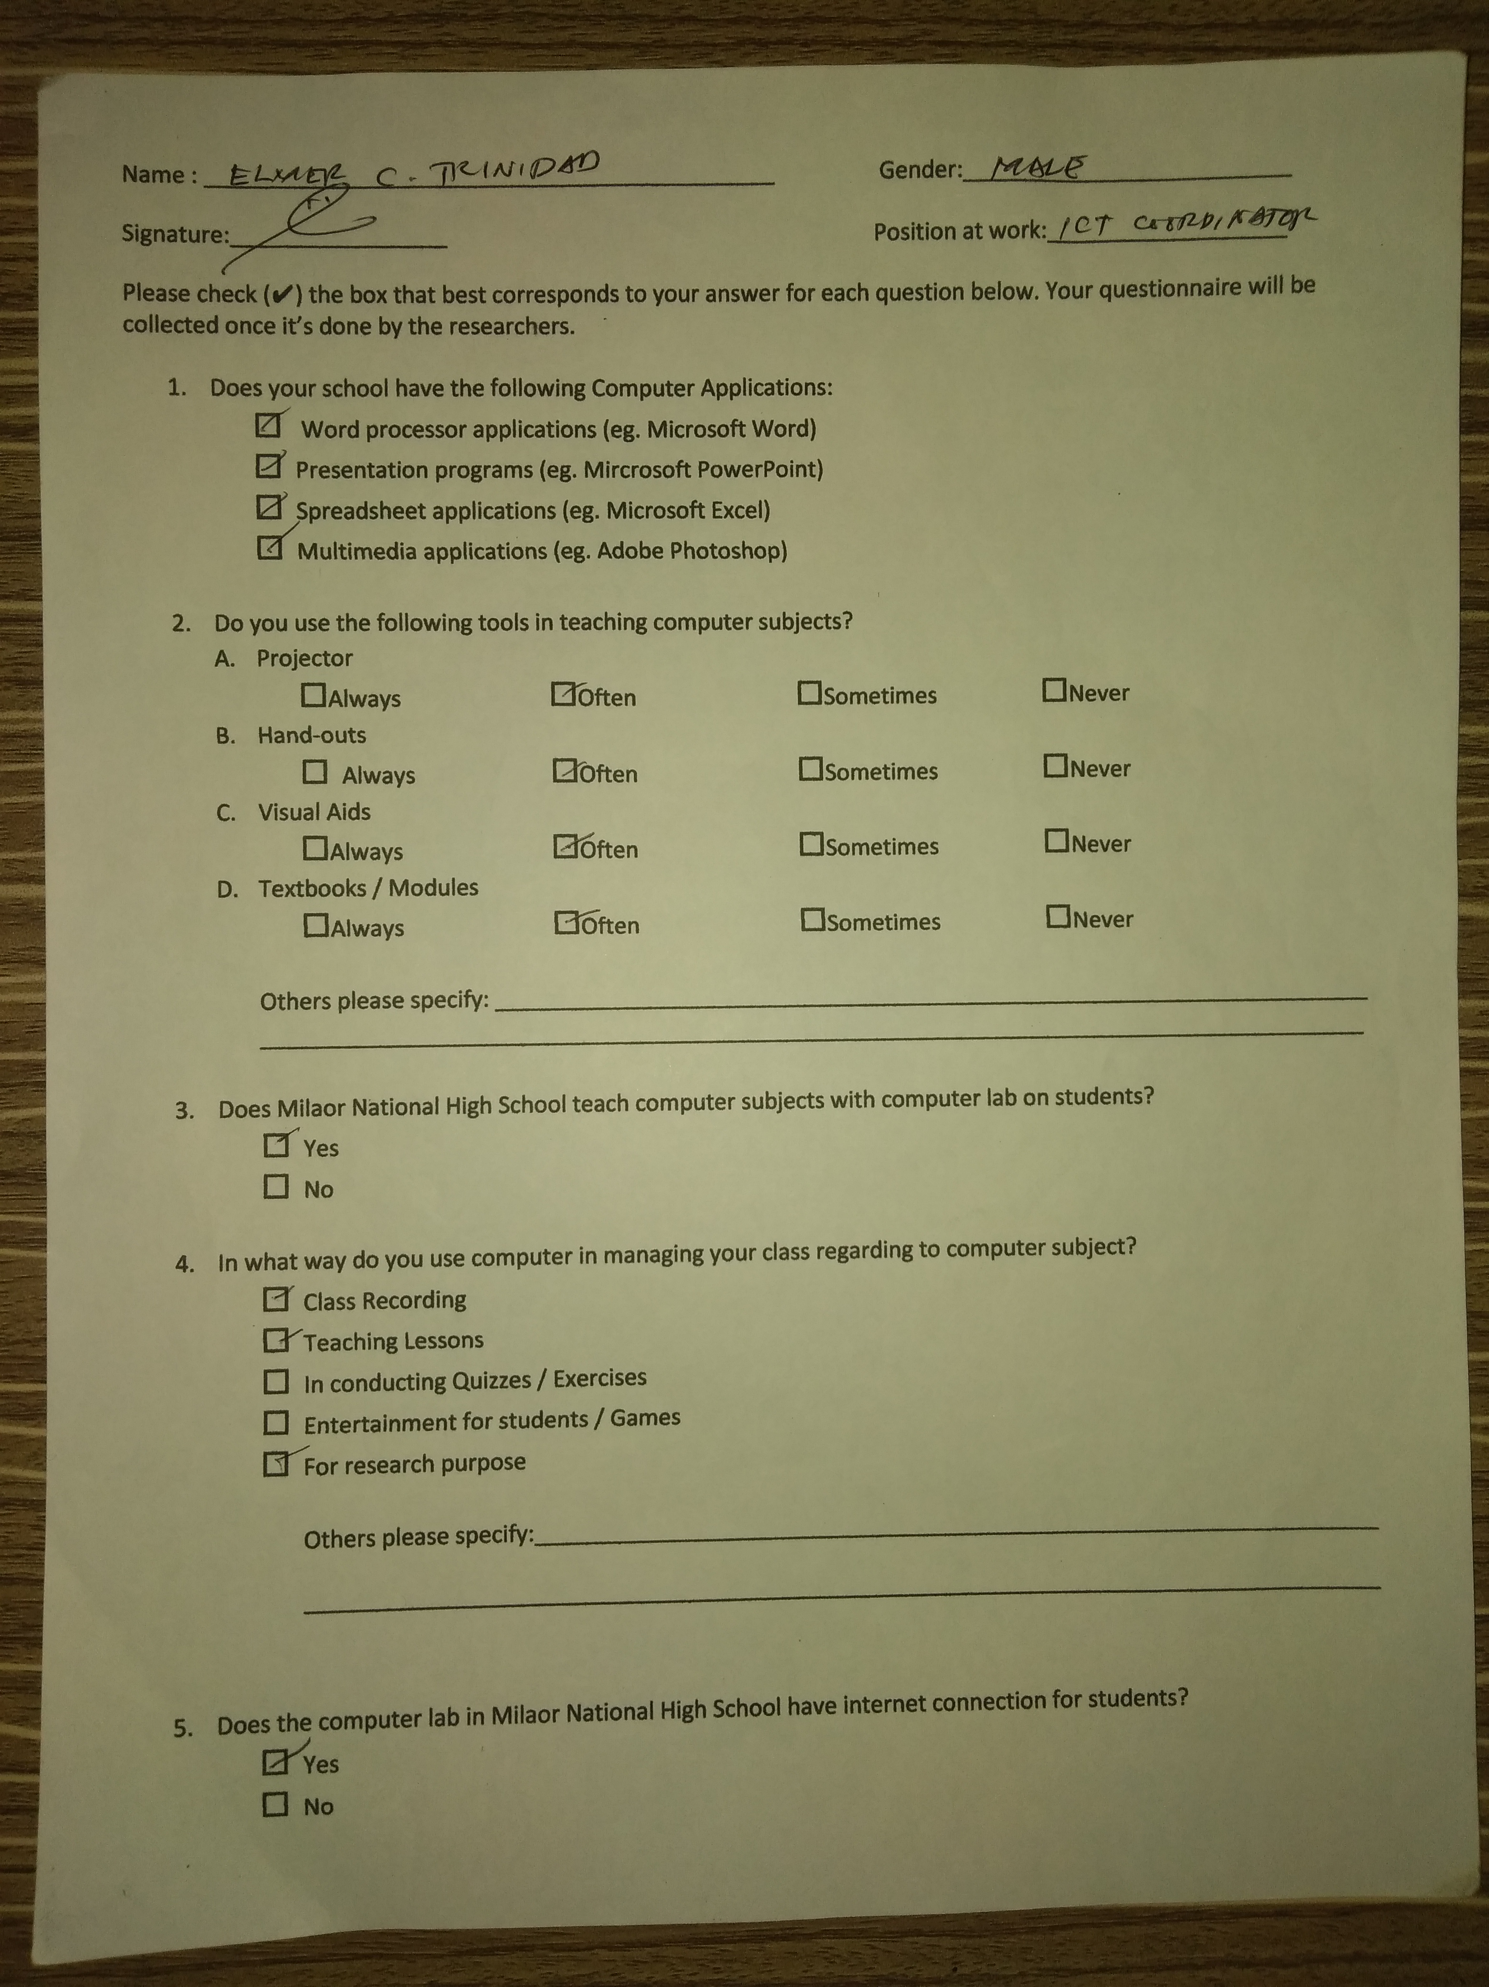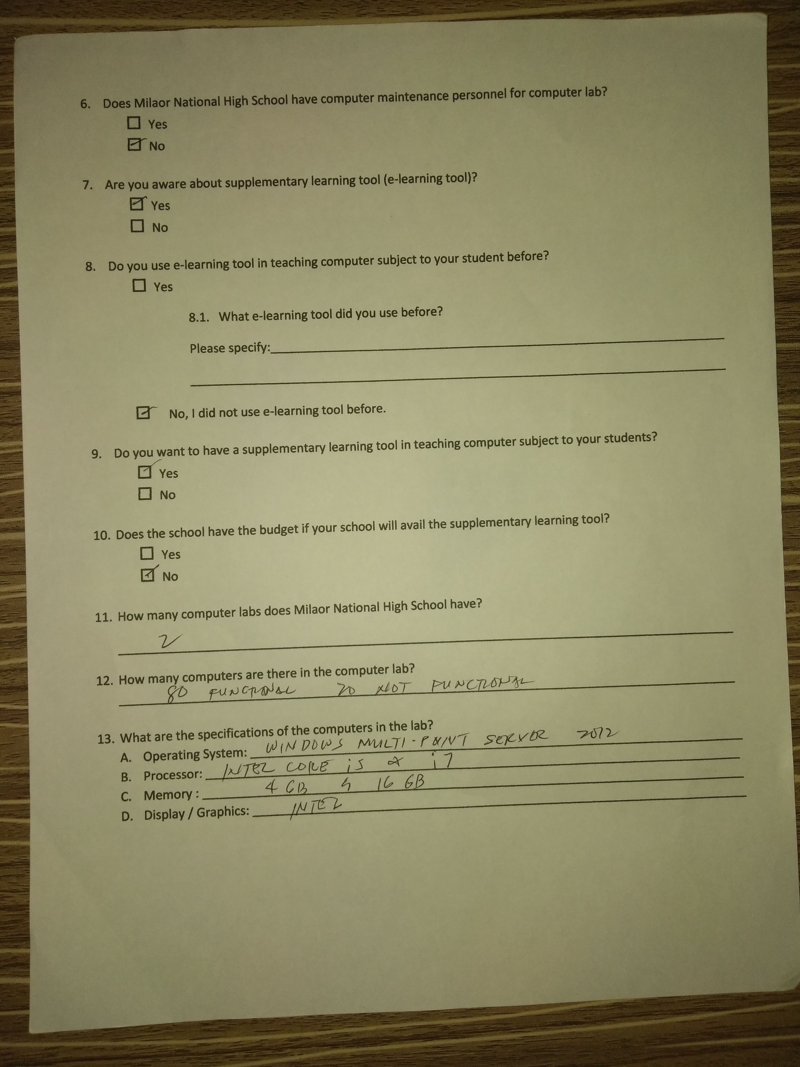

**Sample survey for teacher 2**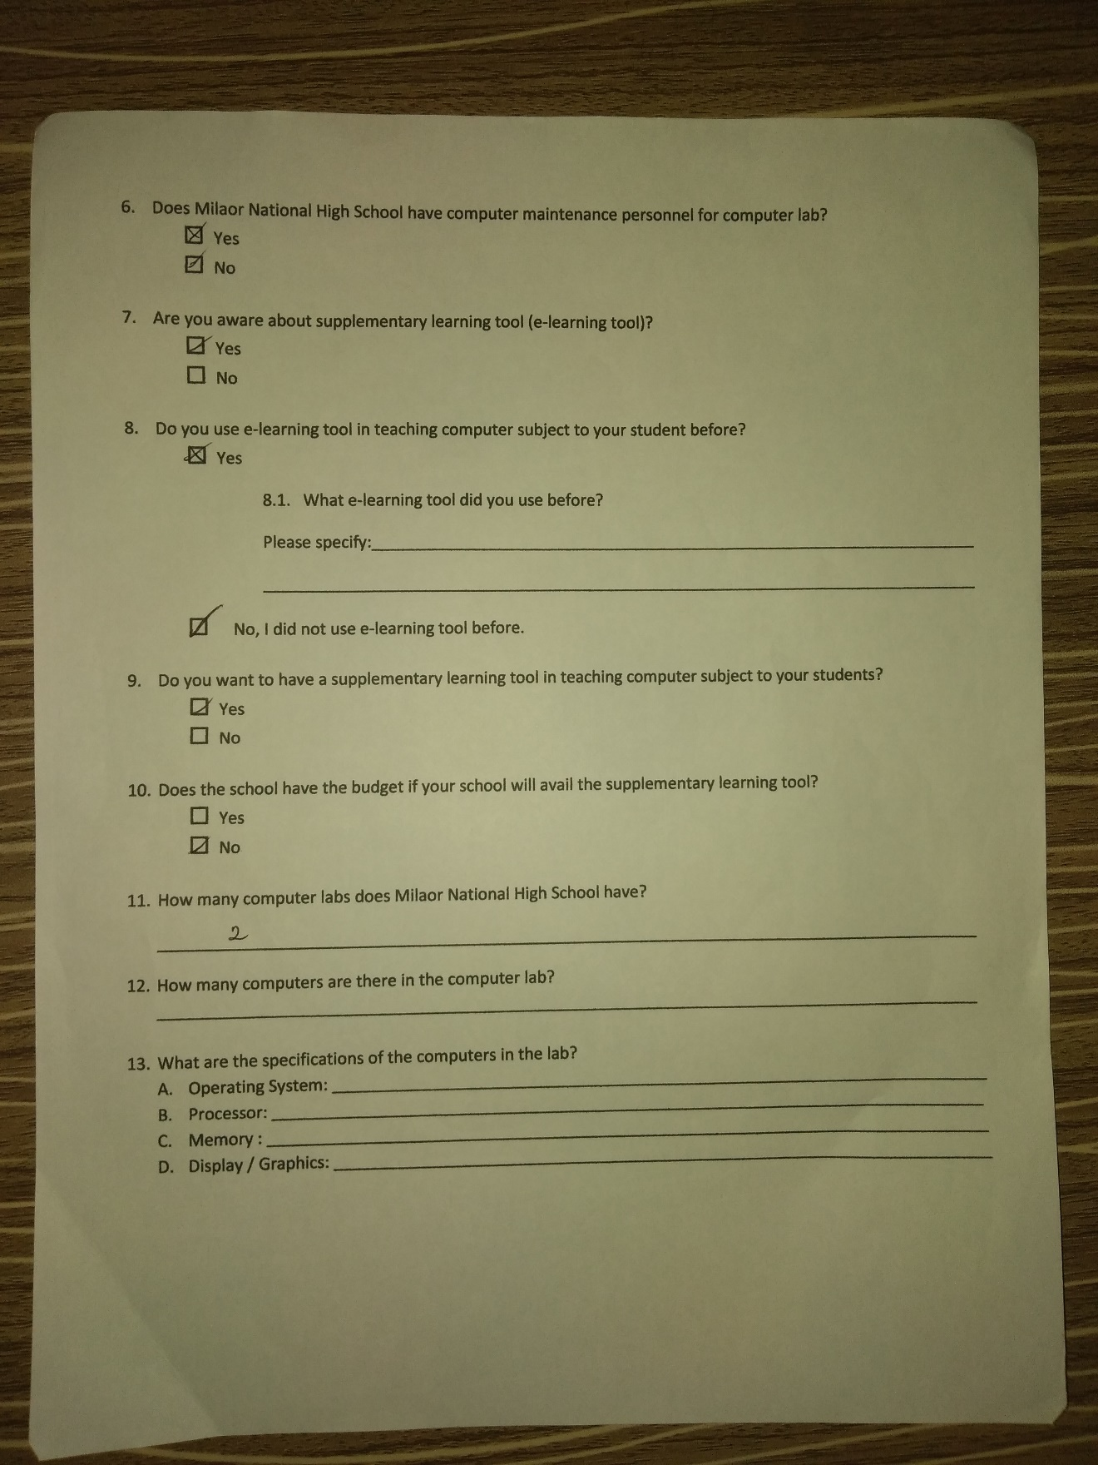

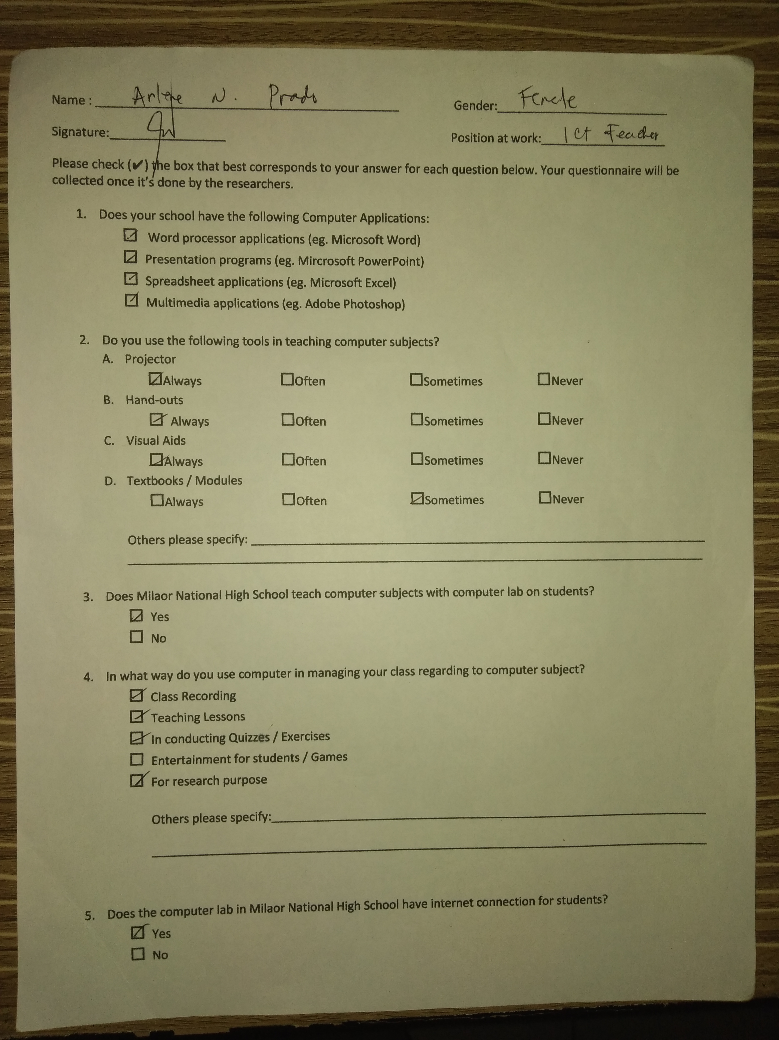

**Student Survey Questionnaire**

Name (optional): ____________________________________________ Gender: ____________

Year Level: ____________________ Signature: __________

Check the Yes box if the given question is true and No if the corresponding question is false.

“Please Be HONEST”

|  |  |  |
| --- | --- | --- |
| **QUESTIONS** | **YES** | **NO** |
| **GETTING STARTED** |  |  |
| 1. Do you have a computer at home? |  |  |
| 1. Do you use some android devices or other latest technologies? |  |  |
| 1. Are you familiar with the basic parts of a computer? |  |  |
| 1. Monitor |  |  |
| 1. Keyboard |  |  |
| 1. Mouse |  |  |
| 1. Printer |  |  |
| 1. System Unit |  |  |
| **TEACHING METHODS** | | |
| 1. Does your teacher used enough time for teaching computer lessons? |  |  |
| 1. Does your teacher use the following language during your Computer subject in   order for you to understand? | | |
| 1. English |  |  |
| 1. Tagalog |  |  |
| 1. Bicol |  |  |
| 1. Does your teacher give home works and project related to computer subjects? |  |  |
| 1. Does your teacher answers correctly whenever your classmate has a question? |  |  |
| 1. Does your teacher conduct recitation, exercises and quizzes regarding to computer topics? |  |  |
| **TEACHING TOOLS** | | |
| 1. Does your teacher use the following tools: | | |
| 1. Projector |  |  |
| 1. Hand-outs |  |  |
| 1. Visual Aids |  |  |
| 1. Textbooks |  |  |
| 1. Do you use the following Computer Applications: | | |
| 1. Word processor applications |  |  |
| 1. Database application software |  |  |
| 1. Spreadsheet applications |  |  |
| 1. Multimedia applications |  |  |
| 1. Does your entire classmate occupy the number of computers in your laboratory? |  |  |
| 1. Does your teacher let you use internet connection during laboratory hours? |  |  |
| **TEACHING PERFORMANCE** | | |
| 1. Does teacher clearly explains instruction and activities whenever there is one? |  |  |
| 1. Does your teacher possess knowledge and skill in computer related topics? |  |  |
| 1. Does your teacher assist or help your classmates whenever there is a problem related to computer topics? |  |  |

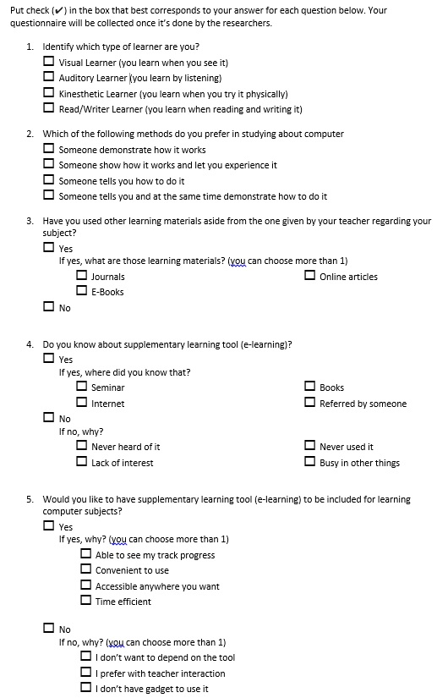

**Sample survey for student**

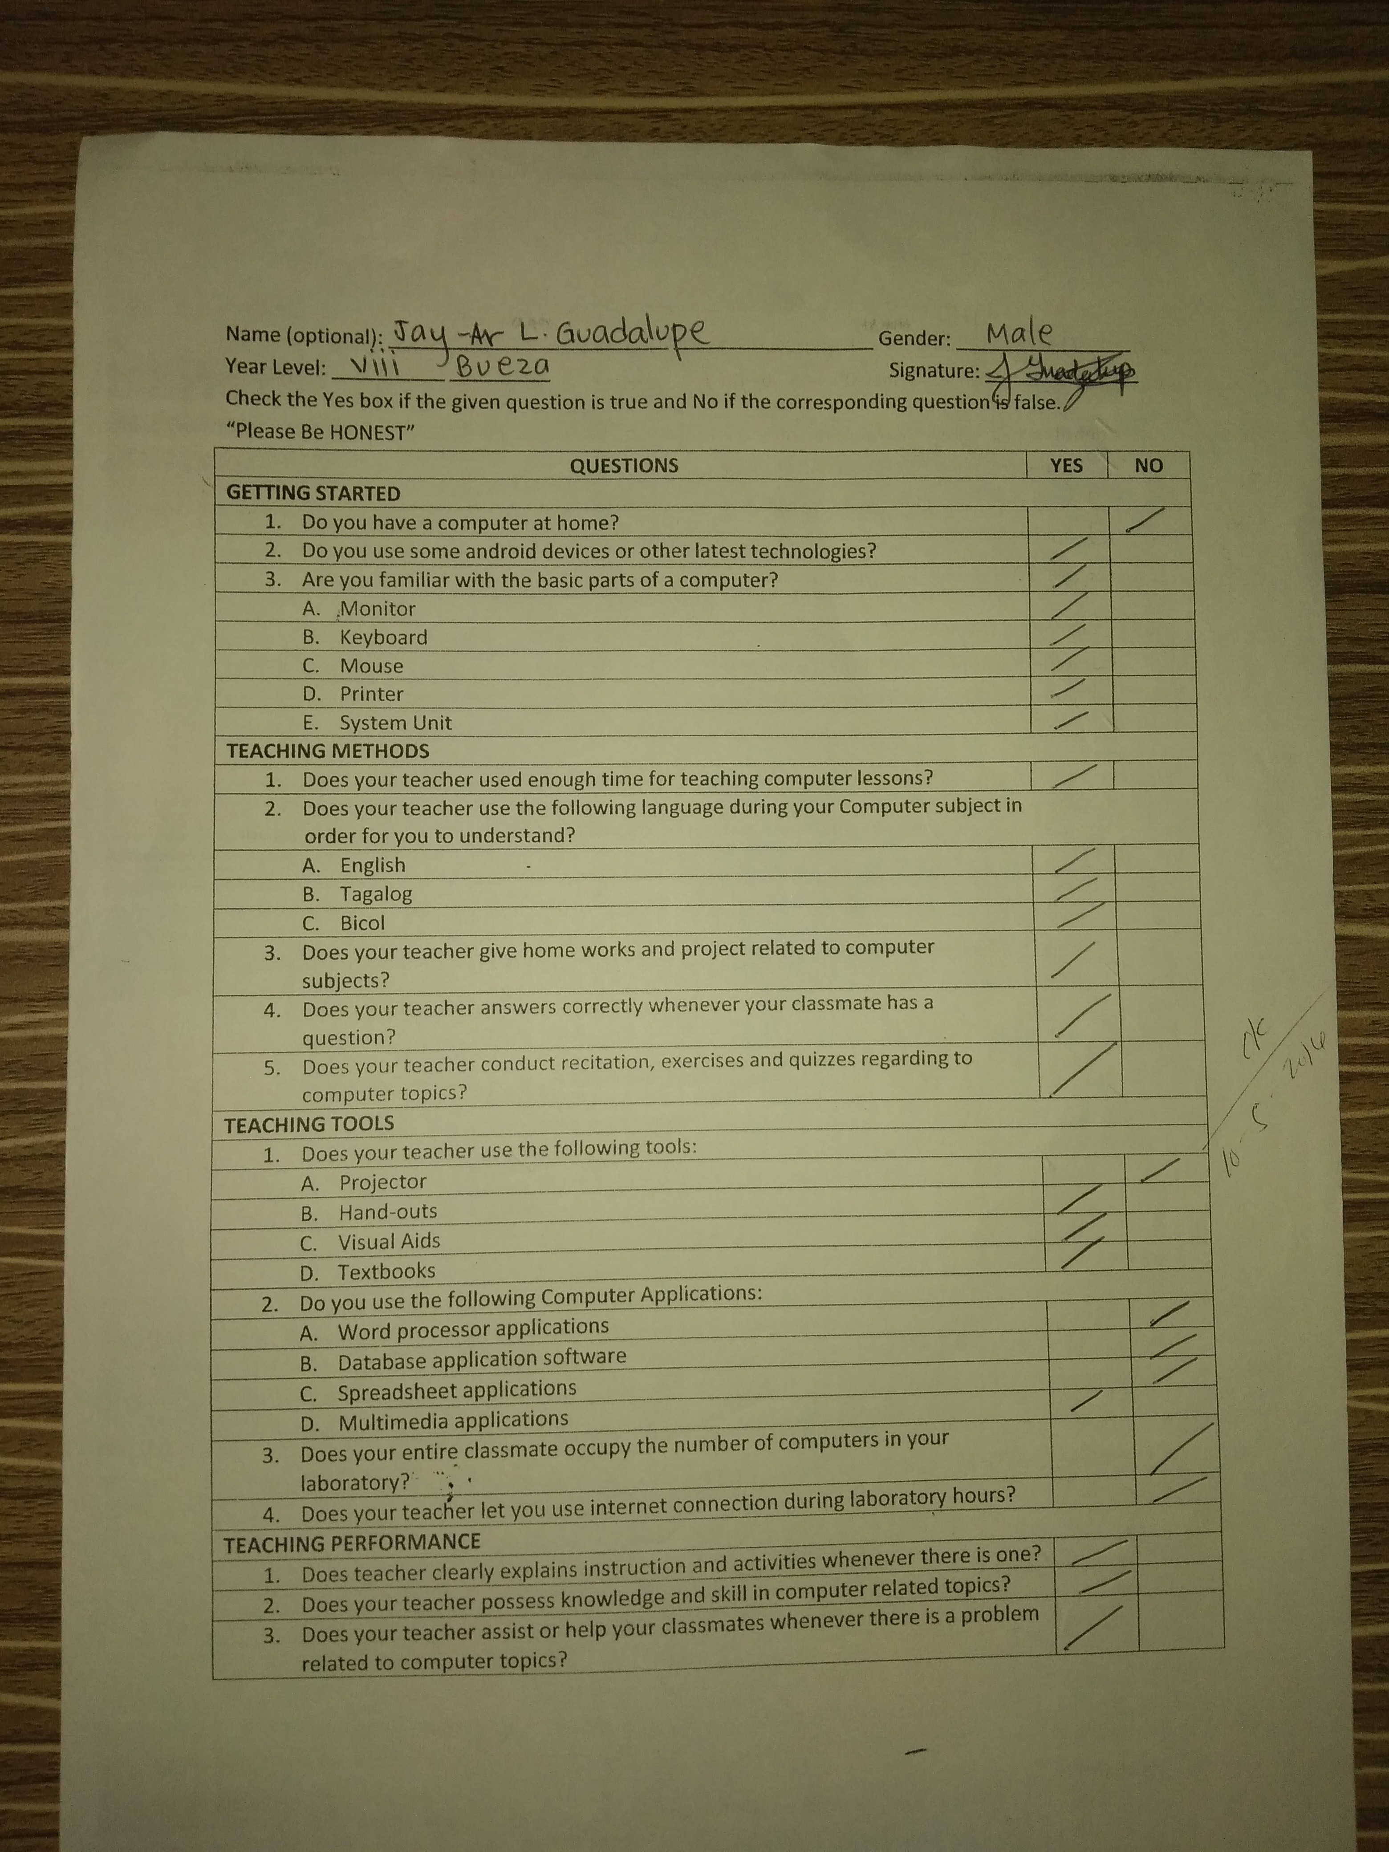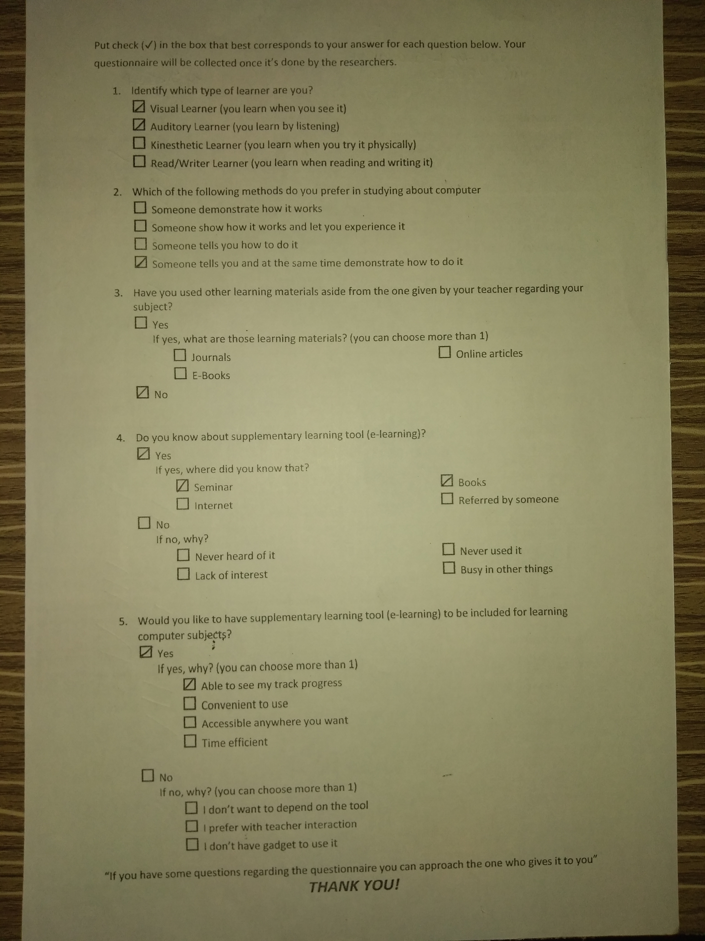

**APPENDIX B**

**Letter for School Principal**

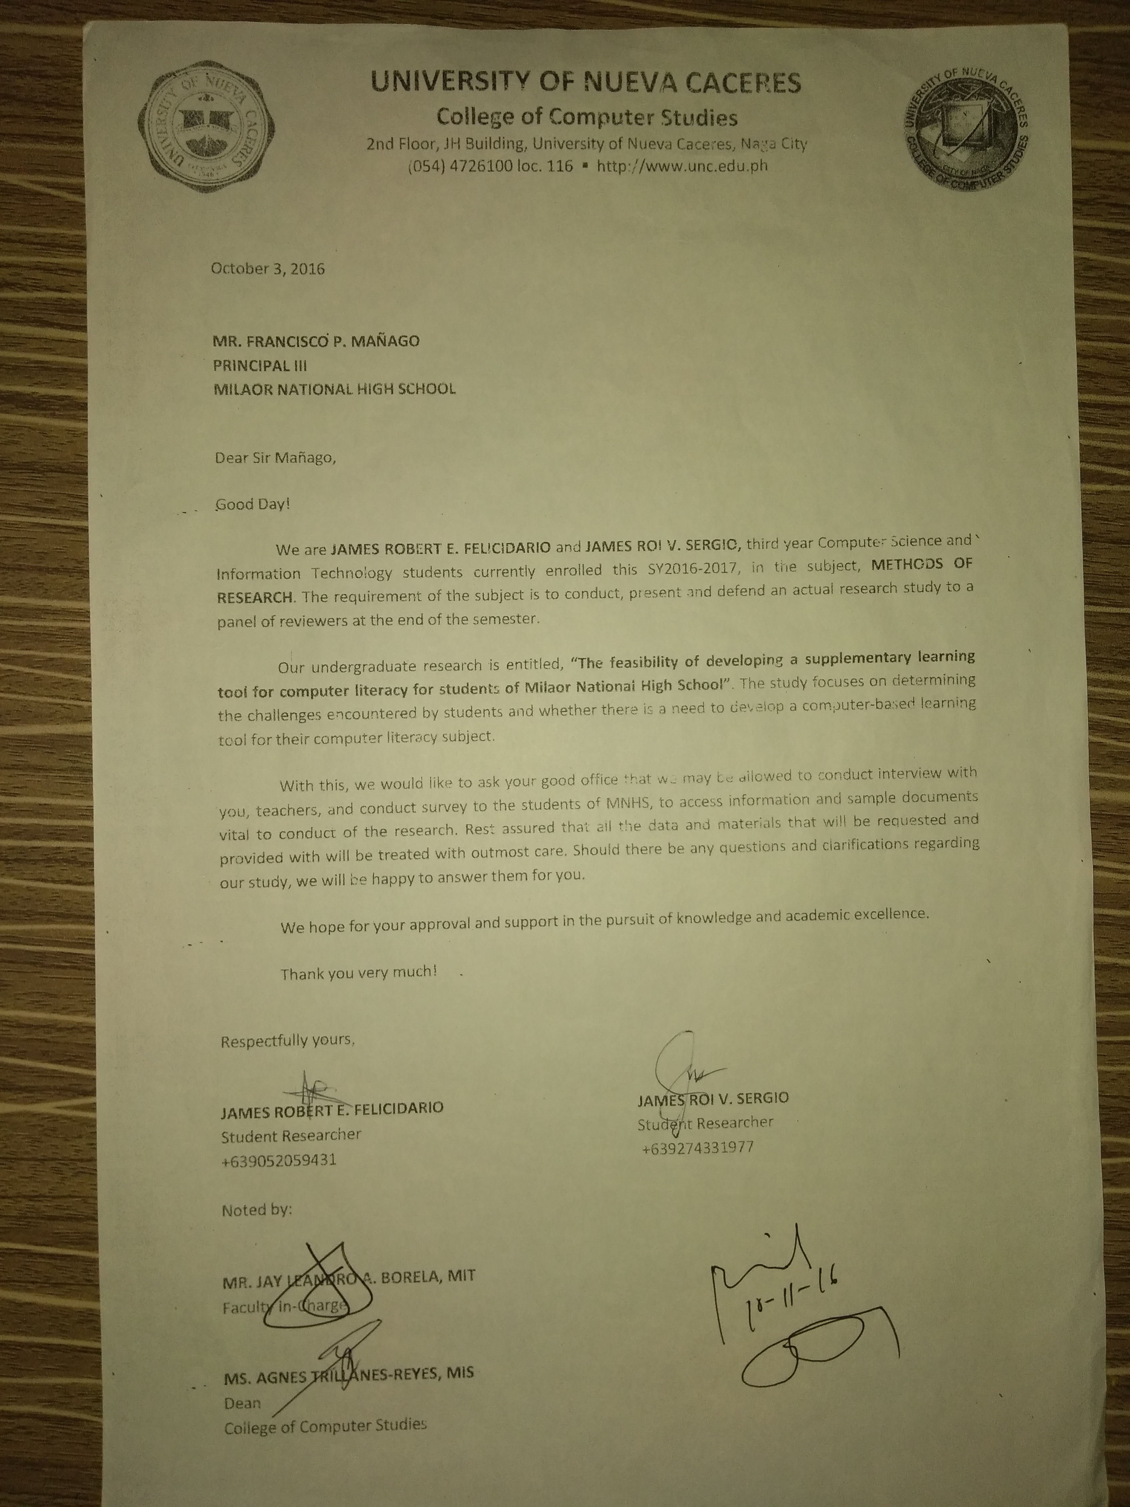

**CURRICULUM VITAE**

**JAMES ROBERT EUSTE FELICIDARIO**

Zone 1, Barangay San Roque, Milaor

Camarines Sur, Philippines

+639052059431

29jamesfelicidario@gmail.com

**PERSONAL INFORMATION**

Birth Date: April 29, 1998

Civil Status: Single

Gender: Male

Religious Affiliation: Roman Catholic

**EDUCATIONAL ATTAINMENT**

Tertiary : Bachelor of Science

Major in Computer Science, 2018

University of Nueva Caceres

Secondary : University of Nueva Caceres, 2014

J. Hernandez Avenue, Naga

Camarines Sur, Philippines

Elementary: Milaor Central School, 2010

Santo Domingo ,Milaor

Camarines Sur, Philippines

**IT SKILLS AND CERTIFICATION**

1. Knowledge in C language and C#

2. Knowledge in Web Development and Multimedia

**JAMES ROI VISTA SERGIO**

Zone 7, Barangay Tabuco, Naga City

Camarines Sur, Philippines

+639274331977

james.sergio@unc.edu.ph

**PERSONAL INFORMATION**

Birth Date: September 30, 1996

Civil Status: Single

Gender: Male

Religious Affiliation: Roman Catholic

**EDUCATIONAL ATTAINMENT**

Tertiary : Bachelor of Science

Major in Information Technology, 2019

University of Nueva Caceres

Secondary : Golden Link College, 2013

Waling-waling st., Barangay 177, Caloocan City

North Metro Manila, Philippines

Elementary: Tabuco Central School, 2009

Tabuco, Naga City

Camarines Sur, Philippines

**IT SKILLS AND CERTIFICATION**

1. Knowledge in C, C++, C# and Java language

2. Knowledge in Database Management System

3. Knowledge in SQL Server, MySQL

4. Knowledge in HTML5, CSS3, Javascript, Bootstrap 4, PHP